Date: 15.07.2022
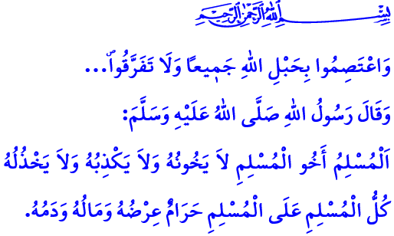
JULY 15: THE VICTORY OF UNITY AND STANDING TOGETHER
Dear Believers!
In the verse I have recited, our Lord Almighty (swt) states, “Hold firmly to the rope of Allah. And do not be divided...”
In the hadith I have read, our beloved Prophet (saw) says, “A Muslim is the brother of another Muslim: he does not betray him, nor does he lie to him, nor does he hold him in contempt. The honor, property, and blood of a Muslim is inviolable for another Muslim.”
Honorable Muslims!
Today is the 15th of July. Exactly six years ago, our nation witnessed a horrible betrayal, beyond historical precedent. The magnitude of the trachery committed by an organization was revealed, which had exploited our nation’s all material and spiritual values for many years under the guise of serving Allah’s (swt) cause, collaborated with external powers and foci of evil to gain strength in various areas, and finally used such power for its own benefits and interests. This network of treachery, FETO, was discovered to have been devising terrible plots to set brothers against one another for half a century. It had worked to divert our youth from their families. It had made attempts to eradicate from their hearts any feelings of love for the homeland, sense of nationhood, and ‘ummah consciousness. But our nation, which has throughout the history overcome countless betrayals thanks to its resoluteness, courage, and self-sacrificing nature, did not let this invasion attempt succeed, too, with the help and grace of Allah (swt), alhamdulillah.
Dear Muslims!
Our Prophet (saw) warns us, لَا يُلْدَغُ الْمُؤْمِنُ مِنْ جُحْرٍ وَاحِدٍ مَرَّتَيْنِ“ The believer should not be stung from the same hole twice.”
Then, let us all be aware of our responsibilities in order not to experience reoccurences of the July 15. Let us learn our religion, Islam, through authentic and realiable sources. Let us live by the Holy Qur’an and the sunnah of our Prophet (saw). Let us pay attention to ensure that our children learn about religion from competent individuals by use of appropriate approaches and methods. Let us not give any opportunity to those evil foci that aim to remove from their hearts the love for the homeland, the sense of being a nation, and of being an ‘ummah. Let us stand together as one body and one heart against those who want to drag our country into sedition and corruption.
Dear Believers!
As in the past, our Presidency of Religious Affairs continues to deliver services by prioritizing our social existence, national unity, peace, and brotherhood above all other benefits and interests. It provides our nation with authentic religious knowledge based on the Qur’an and the sunnah through mosques and Qur’an courses, youth centers, and Family and Religious Guidance officies. It serves as a guide for our great nation’s religious life through khutbahs, sermons, seminars and conferences as well as printed and digital publications. It resolutely continues to fight against the structures that exploit our sublime religion, Islam, and its great values.
يَٓا اَيُّهَا الَّذ۪ينَ اٰمَنُوا قُٓوا اَنْفُسَكُمْ وَاَهْل۪يكُمْ نَاراً وَقُودُهَا النَّاسُ وَالْحِجَارَةُ “O believers! Protect yourselves and your families from a Fire whose fuel is people and stones...” As required by this verse, it endeavors with all its strength to protect, first and foremost, our children, our youth, our families, and all segments of the society from all kinds of violence, supersititions, extremisim, bad habits, and religious exploitation.
Dear Muslims!
Today is the day to embrace each other as a nation and build our future together by regarding our differences as our riches. Today is the day to use our wisdom and foresight to discern between those who are exploiting religion for personal gain and those who are honest and sincere. Today is the day to show our loyalty to our great martyrs and heroic veterans.
As I conclude this Friday’s khutbah, we pray that the mercy of Allah be upon our martyrs, who have from the past to the present sacrificed their lives for our homeland, our nation, and what is sacred for us, and remember both our martyrs and veterans with gratitude.

Al-i ‘Imran, 3/103.
Tirmidhi, Birr, 18.
Bukhari, Adab, 83.
Tahrim, 66/6. General Directorate of Religious Services

